

**Cloud Computing Architecture Lab**

**Name:** Pratham Kandari

**Sap Id:** 500097663

**Batch:** 7

**Experiment -11**

**Create Windows and Ubuntu machine Virtual Machine in Azure and connect to it.**

**Ubuntu**

Step 1) Go to Azure dashboard, click on Virtual Machine.

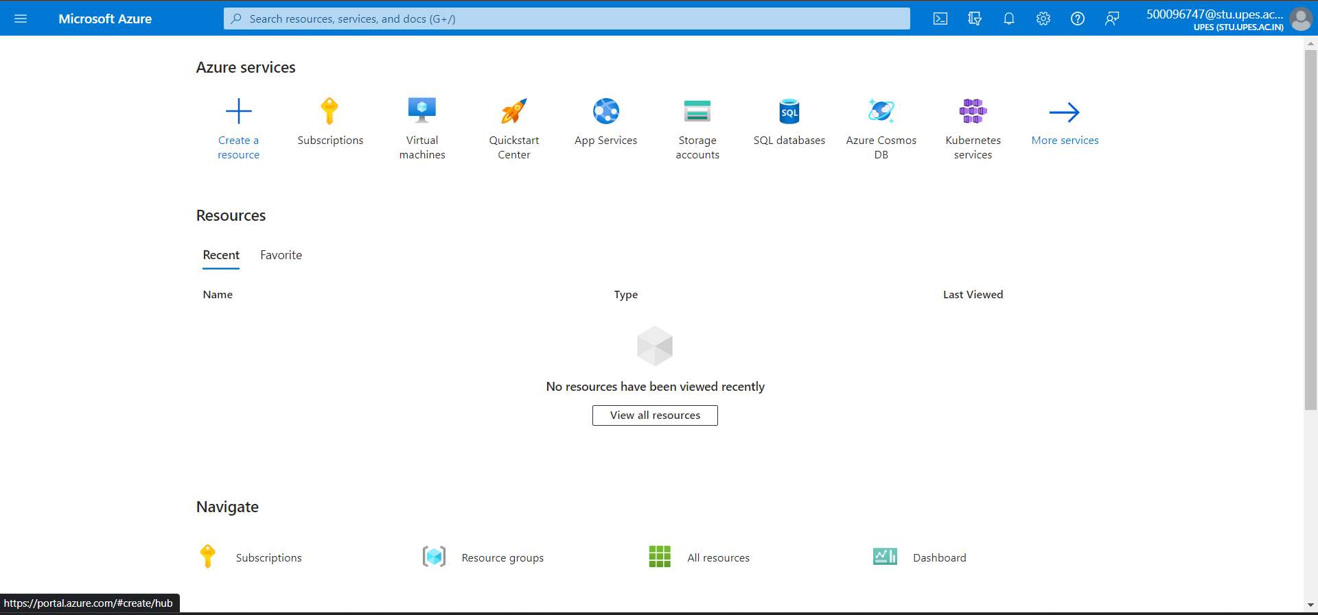

Step 2) Click on create.

Step 3) Select Azure virtual machine.

Step 4) Create a new resource group.

Step 5) Give it a name or let it be default, select image -> ubuntu.

Step 6) Give it a username, password, and key pair name.

Step 7) Under disks select the standard disk type and let everything else be default.

Step 8) Under networking let everything be default and click on next.

Step 9) Under the management let everything be default and click on next.

Step 10) Under monitoring let everything be default and click on next.

Step 11) Under advanced let everything be default and click on next.

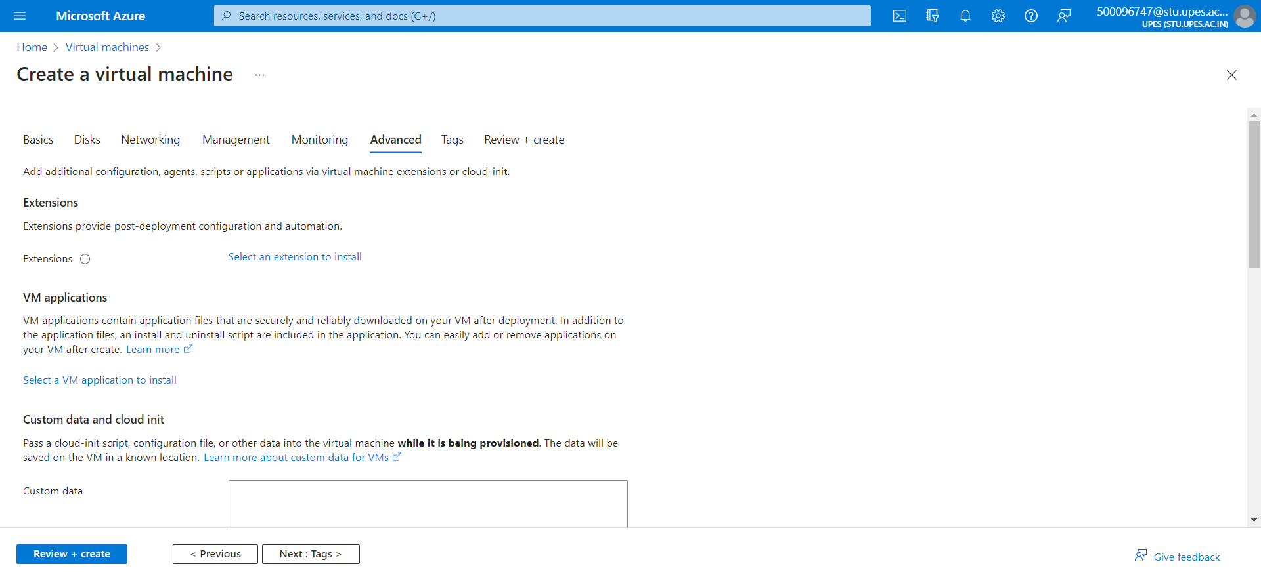

Step 12) Under review+ create review your VM configuration and click on create.

Step 13) Your Vm will be created, click on go to resource.

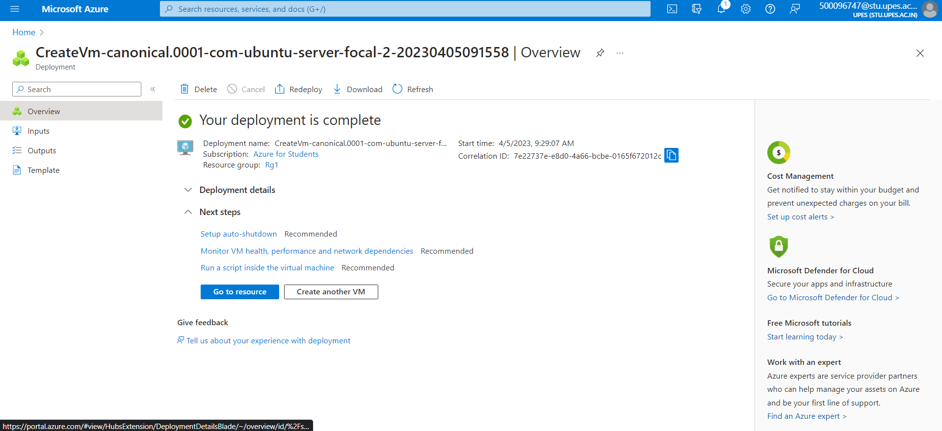

Step 14) Click on Connect.

Step 15) Click on Bastian.

Step 16) And deploy a Bastian.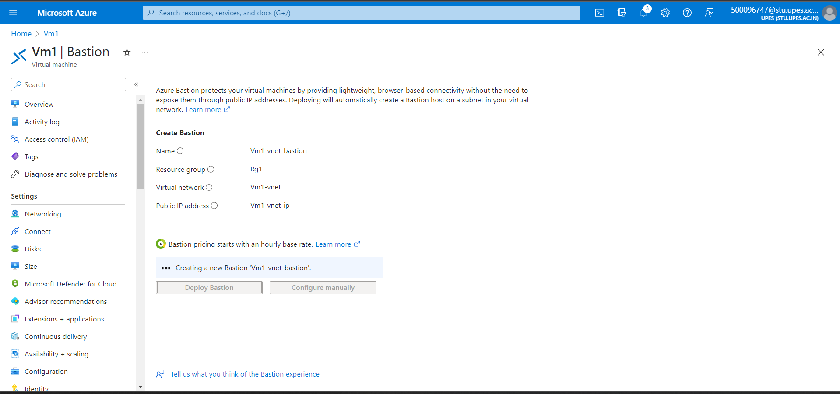

Step 17) Enter the username and browse the local key file and click on connect.

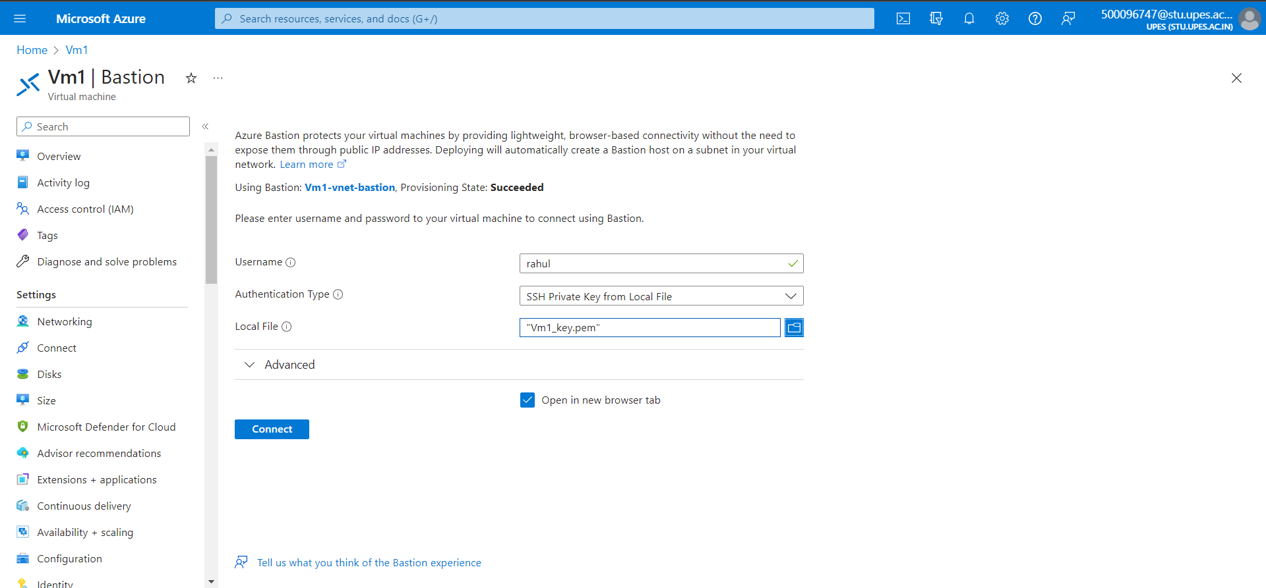

Step 18) Your ubuntu will be launched.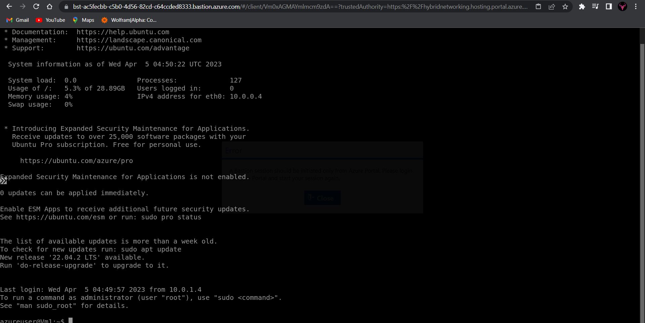

**Windows**

Step 19) Go back to VM and click on create.

Step 20) Select a resource group.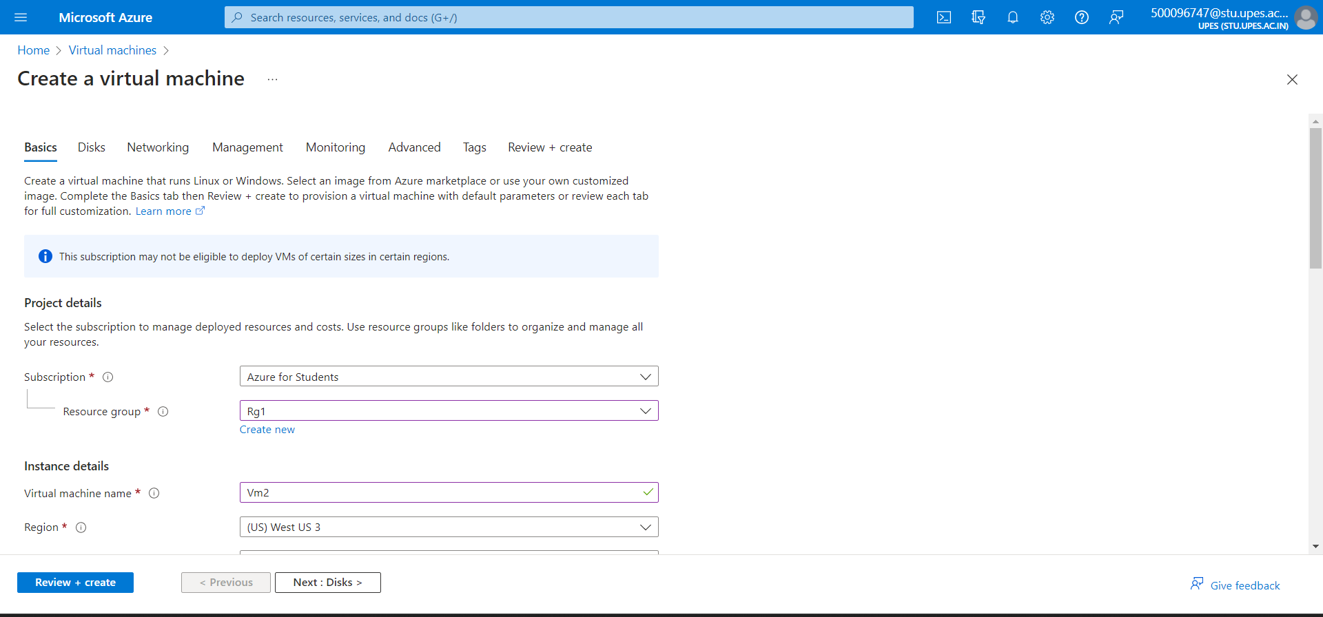

Step 21) Give it a name and select image as windows.

Step 22) Give it a username, password and click on next.

Step 23) Under disks let everything be default and click on next.

Step 24) Under networking let everything be default.

Step 25) Under management let everything be default.

Step 26) Under monitoring let everything be default.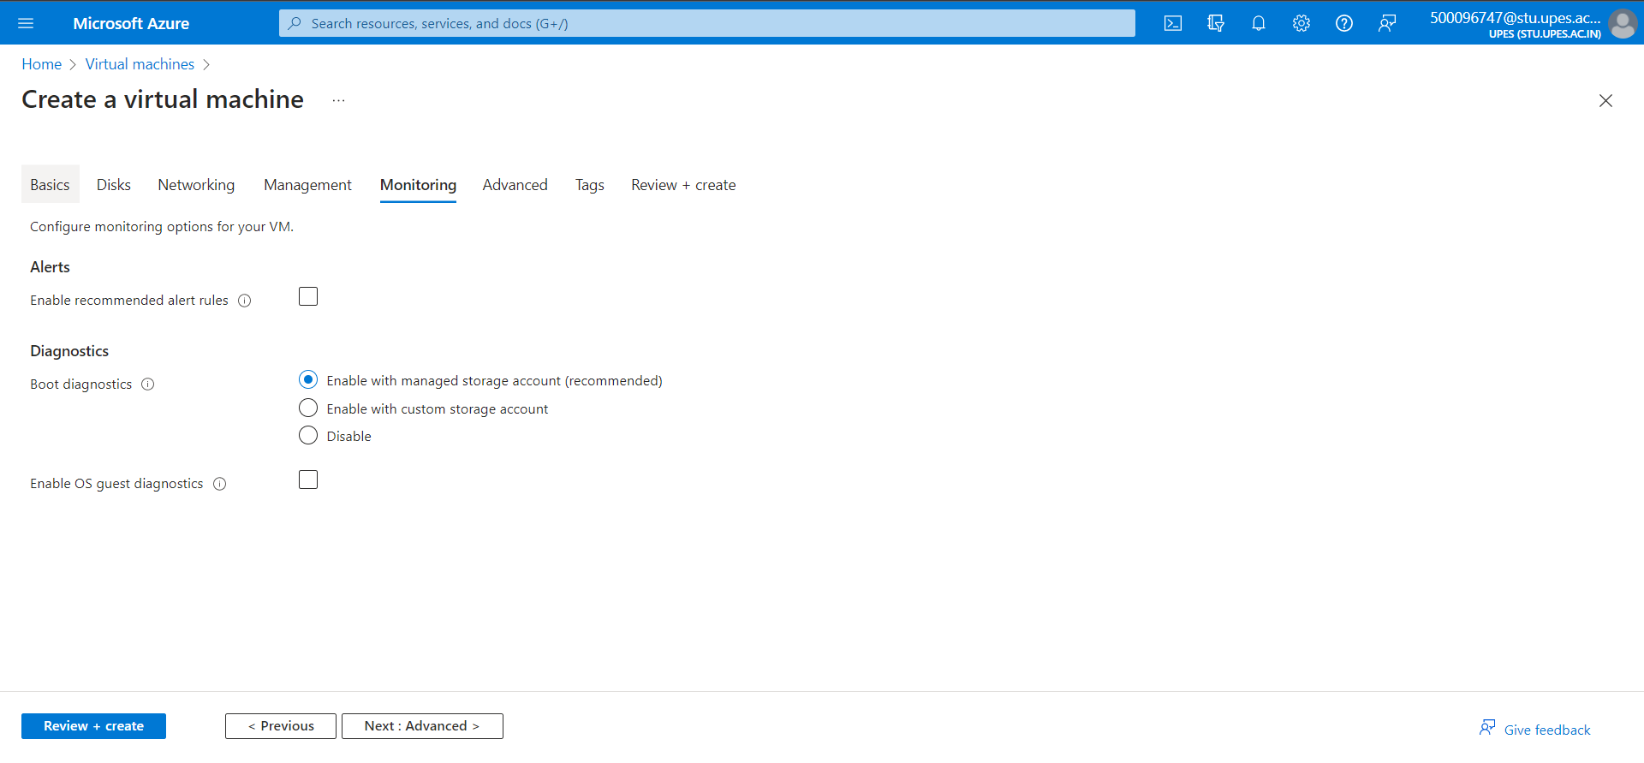Step 27) Under advanced let everything be default and click on next.

Step 28) Under Review+create review your Vm configuration and click on create.

Step 29) Go to your VM Overview.

Step 30) Go to Connect -> Bastian. 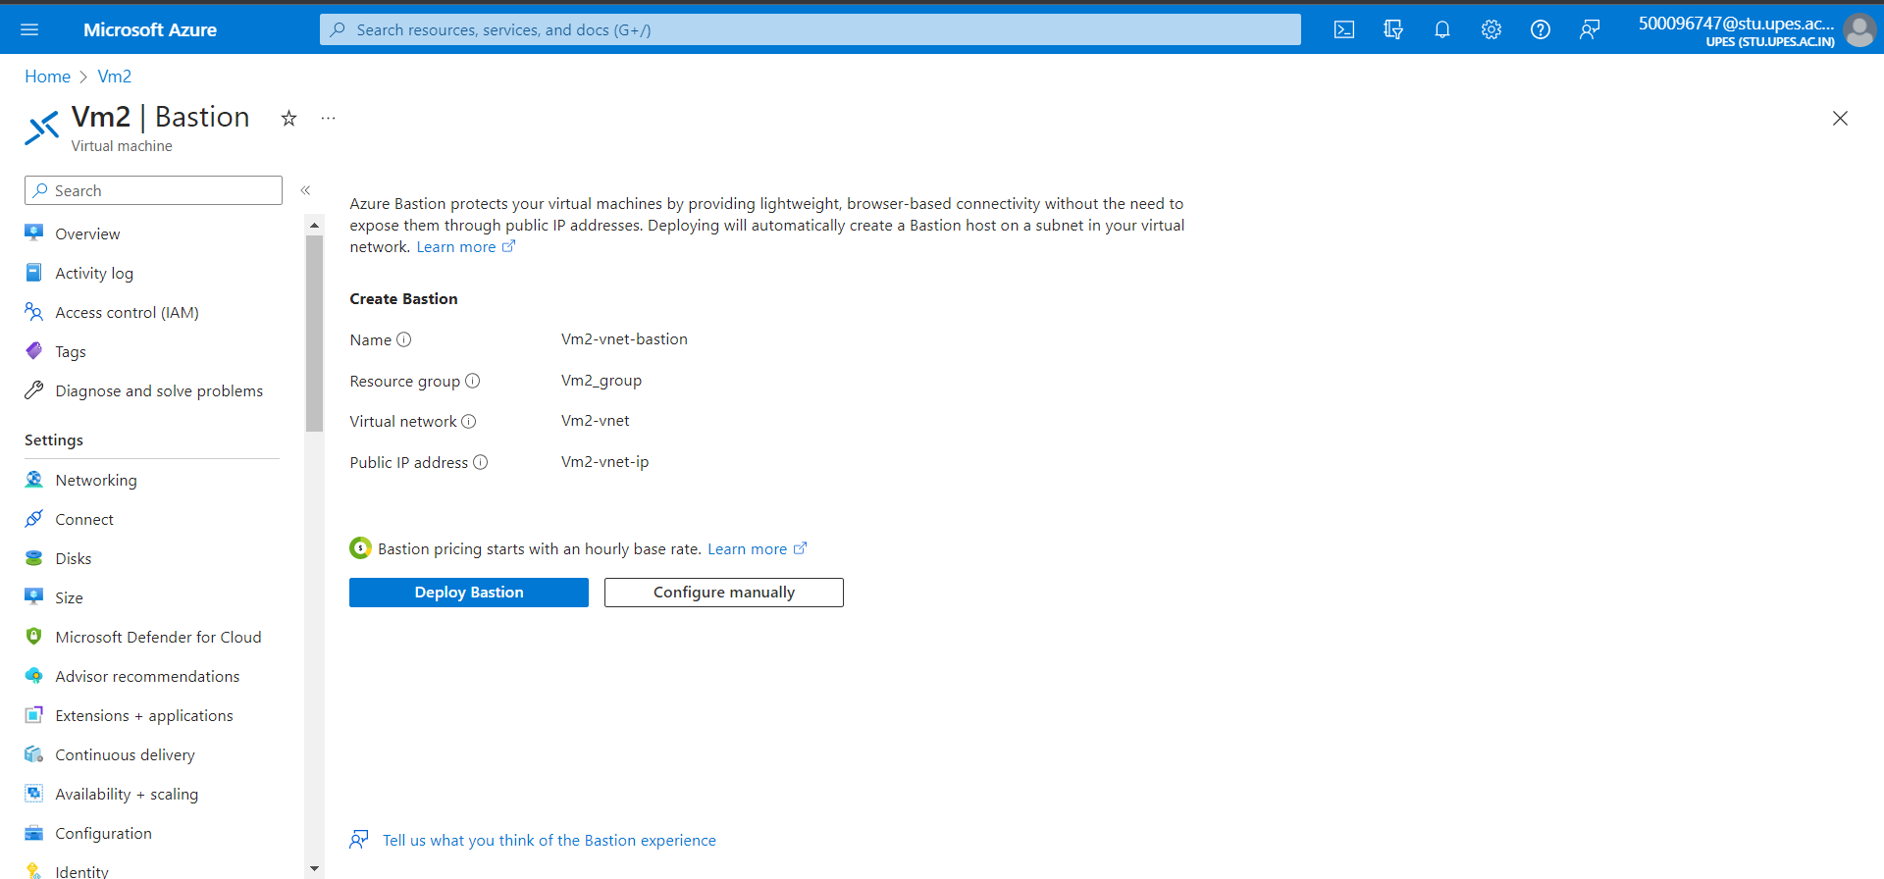

Step 31) Enter username, password and connect.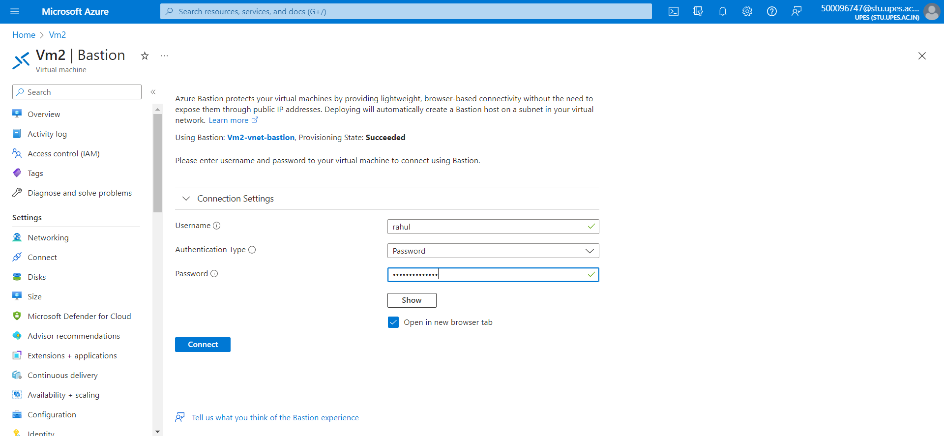

Step 32) Windows window will open.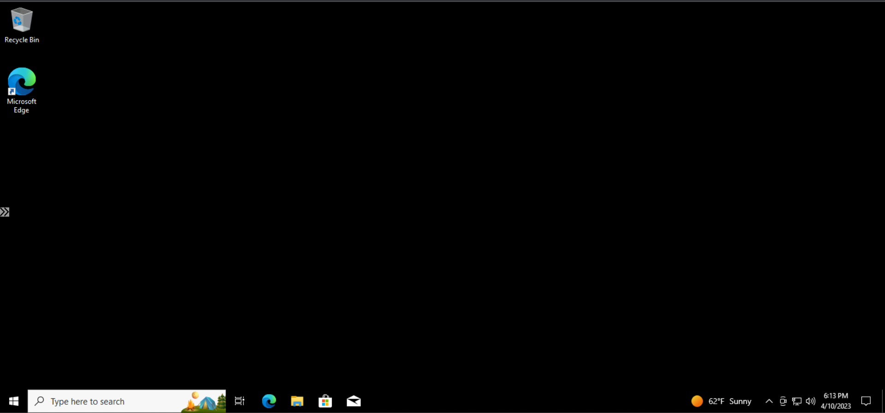

Step 33) After using VM delete the VM.

